 | SAMPLE Practical TEST  ISCG6420 Internet and Website Development
Department of Computing | Time Allowed: 1 hour 30 minutes plus 10 minutes reading time  Weighting: 30%  Marks: 100

Please fill in your name and your exam code.

Your Name is: ___________________

Your Exam Code is: ___________________

Instructions:

1. | This is an open book test.
2. | Please use your EXAM login assigned by your lecturer. All the given files are in the Test Files folder.
3. | In this test, you will create a website for Women Bags which is a fictitious company. There are eight tasks in this test. You should complete all the tasks. You should attempt all the requirements.

Summary of paper:

Tasks | Topics | Marks
Task 1 | Index Page | 10
Task 2 | CSS Menu | 10
Task 3 | Add Header Board | 14
Task 4 | Work on Index Page | 20
Task 5 | Process Photos | 12
Task 6 | Display Bag Page | 10
Task 7 | About Page | 8
Task 8 | Membership Form | 16
 | TOTAL MARKS | 100

Task 1 Index Page 10 marks
Instructions

You need to use Adobe Dreamweaver for this task.

- Please include the given bag.css as an external CSS file. (1 mark)

- Create an index.html page which has one headboard and three columns as shown in the given file PageLayout.jpg. You need to write the HTML code by using a division for each area and using the CSS styles defined for each division in the given file bag.css. (4 marks)

- Inside the given file bag.css, define a CSS class heading which will have an appropriate font face, font size and centred. Use this class and add a heading “Women Bags” to index.html. (4 marks)

- Please add a proper title to index.html. (1 mark)

Task 2 CSS Menu 10 marks
Instructions

You need to use Adobe Dreamweaver for this task. In this task, you will create a menu for your website by using CSS. The menu is similar to the following:

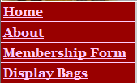

- Continue to work on index.html. You should display the menu as an unordered list by using the given CSS code. You should add the code related to the menu in the left column of the page. Each menu item will be a link. (3 marks)

- When Home is clicked, file index.html will be displayed. When About is clicked, file about.html will be displayed. When Membership Form is clicked, file membership.html will be displayed. When Display Bags is clicked, file display.html will be displayed. (4 marks)

- Inside file bag.css, please define appropriate text font, text size, color and background color for page body. Please set margin and padding as 0px. (3 marks)

Task 3 Add Header Board 14 marks
Instructions

You need to use Adobe Dreamweaver for this task. In this task, you will display the header board image.

- Continue to work on index.html. Include the given javascript file bag.js in the head of index.html. (1 mark)

- Create a folder images. Copy given images bag_banner1.jpg, bag_banner2.jpg, bag_banner3.jpg, bag_banner4.jpg, bag_banner5.jpg, bag_banner6.jpg into this folder. (2 marks)

- Display image bag_banner1.jpg in the headboard division with width="728", height="90", name and ID as “logo” (2 marks)

- When the page is loaded, function fading_rotating() should be called, which is defined within file bag.js. You should see the six images rotating here. (2 marks)

- Inside file index.html, please include the given file SpryEffects.js as an external file. Inside file bag.js, please call function Spry.Effect.DoFade properly such that the images will be fading so that they are almost invisible after each rotating. (4 marks)

- Save index.html as membership.html, display.html and about.html respectively.
(3 marks)

Task 4 Work on Index Page 20 marks
Instructions

You need to use Adobe Dreamweaver for this task. In this task, you will work on index.html page, the outcome of which is similar to the following:

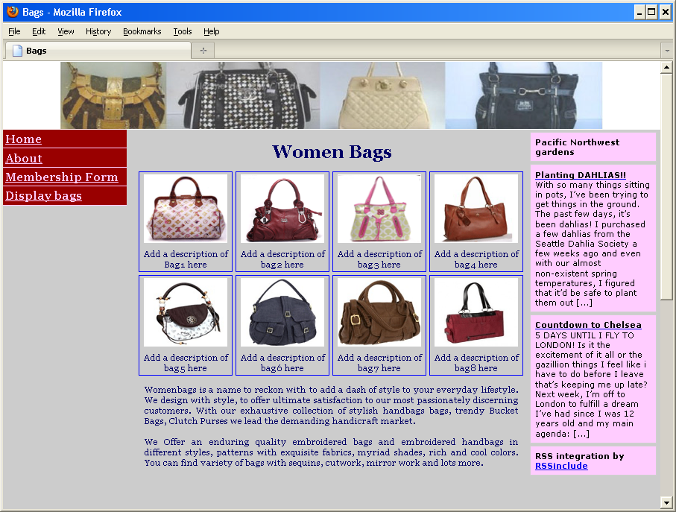

- Continue to work on index.html page. Copy all the code from Code.doc to the middle column after the heading. Copy given image files bag1.gif, bag2.gif, bag3.gif, bag4.gif, bag5.gif, bag6.gif, bag7.gif, bag8.gif into images folder.
(4 marks)

- Add the text in the Home Page section of file Information.doc to the bottom of the middle column in this page. Please put the text in a division and apply CSS class description which is defined in the given CSS file bag.css to the division.
(4 marks)

- Please call function changepage(i) properly, which is defined within file bag.js, such that when an image is clicked the corresponding URL will be opened within a new window. (6 marks)

- Modify file index.html and bag.js, so that they still work correctly for all the eight images provided. (6 marks)

Task 5 Process Photos 12 marks
Instructions

You need to use Adobe Photoshop for this task. In this task, you will create images for a bag slide show.

- Start Photoshop. Open given image file slide1.jpg. Use Window | Actions tool to create new action set and action name to record following steps applied to file slide1.jpg.
- Add a rectangular border to the file slide1.jpg image with some effects. The border color should be white. Please make sure that the image size (450x450) is not changed. (6 marks)
  - Choose File | Automate | Batch to run the above recorded batch on image file slide2.jpg, slide3.jpg, slide4.jpg, slide5.jpg, slide6.jpg and slide7.jpg. Make sure all the above images should have same border effect. All the border results should be similar to the following image: (4 marks)
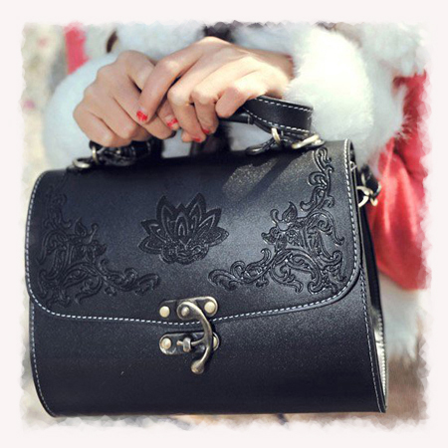

- Copy all above image files into images folder (2 marks)

Task 6 Display Bag Page 10 marks
Instructions

You need to use Adobe Dreamweaver for this task.
In this task, you will work on display.html, the outcome of which is similar to the following:

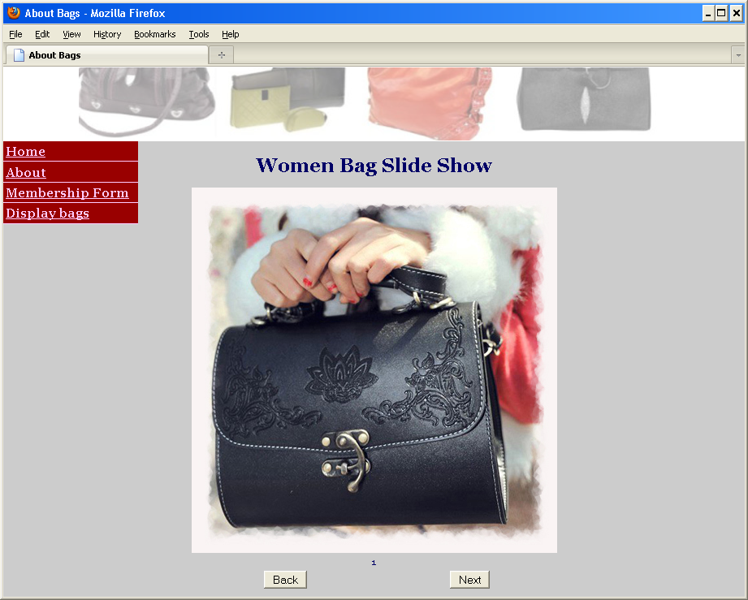

- Open display.html page. Use the predefined CSS class heading and add a heading “Women Bag Slide Show” to display.html page. Add a proper title to display.html. (2 marks)

- Copy all the code from Table.doc to the middle column after the heading.
(2 marks)

- Define function goforward() within file bag.js, and call it from display.html such that when Next button is clicked the next image should be displayed in order slide1 to slide2 ... slide7.
(6 marks)

Task 7 About Page 8 marks
Instructions

You need to use Adobe Dreamweaver for this task. In this task, you will work on about.html page, the outcome of which is similar to the following:

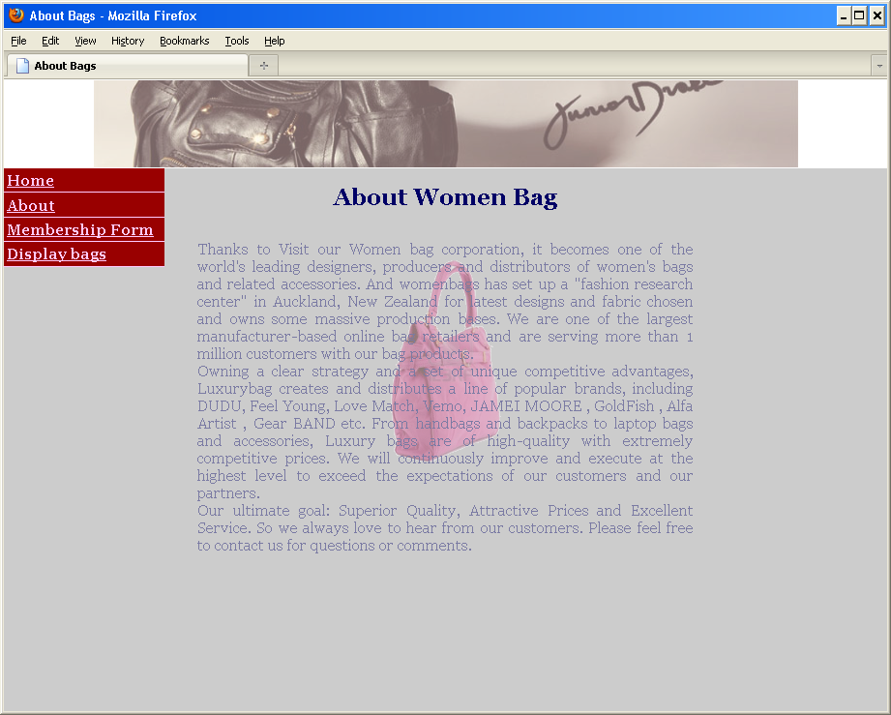

- Open about.html page. Use the predefined CSS class heading and add a heading “About Women Bags” to about.html page. Add a proper title to about.html.
(2 marks)

- Add the text in the About section of file Information.doc to a transparent box with a background image background-bag.gif (given), into the middle column after the heading. Add the correct JavaScript event handlers such that when the mouse is over the box, the box will be fully visible, when the mouse is out of the box, the box is back to being partially visible. It should work for IE and other browsers. Make use the predefined division ID transbox from the given file bag.css. (6 marks)

Task 8 Membership Form 16 marks
Instructions

You need to use Adobe Dreamweaver for this task. In this task, you will add a feedback form, the outcome of which is similar to the following:

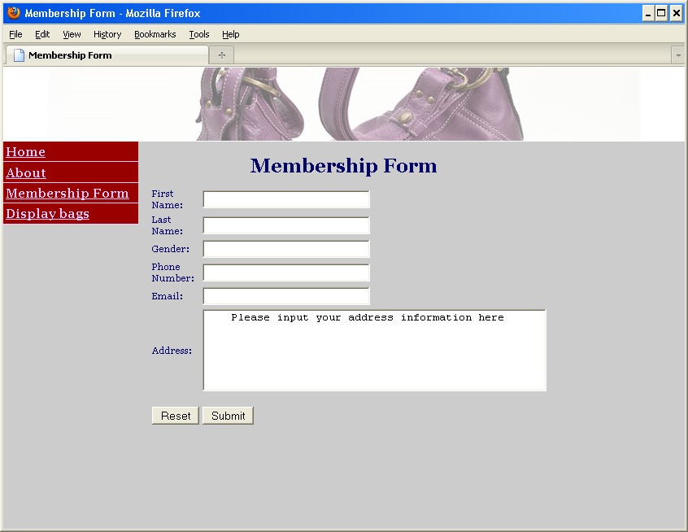

- Open membership.html page. Use the predefined CSS class heading and add a heading “Membership Form” to membership.html page. Add a proper title to membership.html. (2 marks)

- Add the above form to the middle column of this page after the heading.
(4 marks)

- There is a function validate_form defined in the given file bag.js. This takes the form as a parameter and checks the Email Address field of the form by calling function validate_email(field,alerttxt). If the email address is not valid, it will display the message “The input email address is not valid!” and then set the cursor focus to the email field. Add a function validate_email(field,alerttxt) to file bag.js, which checks if the input email address contains a symbol “@” and a “.”. The first “.” must be at least three characters away from the “@”, if the email address is invalid, the given “alerttxt” will be displayed. (5 marks)

- Call the function validate_form when the form is submitted. (2 marks)

- Create and validate two new fields, URL & Date of Birth, by making use of the HTML5 input control validations. (3 marks)

